Guidance for operating a temporary foodservice event on the UNT campus shall be as follows:
- Only approved food products will be permitted. Home preparation or the storage of food in the home is not allowed.
- All TCS (time and temperature controlled for safety) foods shall be maintained under proper temperature control: hot foods maintained at 135°F or hotter and cold foods maintained 41°F or colder. Thermometer to check temperature is required, in addition to thermometer probe cleaning wipes.
  - Additional documentation and process review will be required when using time as a public health control. Contact angela.sietsema@unt.edu for information and approval.
- Food shall be protected at all times. Foods must remain covered when not serving. All food and utensils maintained 6” off floor/ground. Outdoor setups must be covered and on a non-absorbent surface (such as concrete, asphalt, or tarp covered grass).
  - All condiments, including relish and ketchup, available for customers shall be single-service packets or be dispensed from sanitary dispensers. Must provide single service plates & utensils.
- Must not use ice as a food ingredient that is used to cool exterior of bottles and cans. Must have handle on scoop used to dispense ice that is maintained out of the ice at all times.
- All employees shall:
  - Wear clean clothes and hair restraints; hats and beanies permitted as a hair restraint.
  - Wear nothing on hands and wrists (no watches/bracelets). However, one ring may be worn that is a plain band, without stones or embellishment.
  - Wash hands with soap and water prior to beginning work, after smoking, eating, or drinking, changing tasks, and after using the restroom.
  - Use disposable gloves and/or clean (washed, rinsed, sanitized) utensils when handling food products. Ensure that utensils are stored on sanitized surface and stored within food during breaks in service.
    - No bare hand contact with ready to eat foods!
  - Smoking or use of tobacco products inside concession stand is prohibited.
- Must have either 3 compartment sink or approved 3 bin set up available for cleaning dishes and utensils:
  - WASH : Soapy water for washing
  - RINSE: Rinse in clear water
  - SANITZE: Concentration and time determined by manufacturer. Must have test strips to verify concentration. Open container of bleach water tested/replaced every 4 hours.
- Must have an adjacent hand sink (not located in a bathroom), or have an approved setup: gravity flow container with spigot, full of clean water and with catch basin. Equipped with soap, paper towels, and trash.
- All trash and garbage must be contained in leak proof container and remain covered when not in use.
- Toxic items and chemicals shall be stored away from food and food supplies.
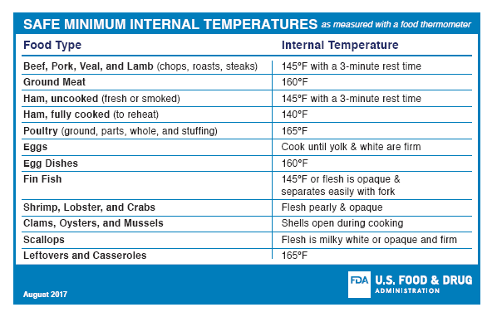
Retain this document for future reference.

